A
PROFESSORA: Fernanda e Jéssika.___________

5º Ano – Fundamental I

COLÉGIO SANTA DOROTÉIA
Educar, um gesto de amor que fica para sempre.
Disciplina: Língua Portuguesa.

Nota:
Data: / /
Nº:
Nome:

- Leia o texto a seguir:
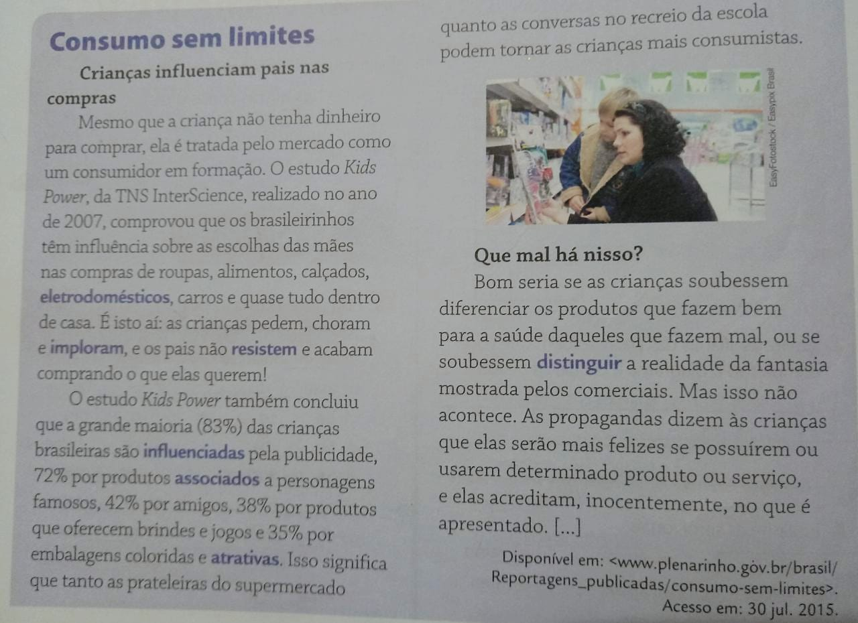
1°) Pesquise o significado das palavras no dicionário:
- Associado:__________________________________________________________________________________________
- Atrativo:___________________________________________________________________________________________
- Distinguir:__________________________________________________________________________________________
- Eletrodoméstico:_____________________________________________________________________________________
- Implorar:___________________________________________________________________________________________
- Influenciar:_________________________________________________________________________________________
-Resistir:____________________________________________________________________________________________

2°) Escreva com suas palavras o objetivo do estudo Kids Power.
______________________________________________________________________________________________________
______________________________________________________________________________________________________________________________________________________________________________________________________________
3°) Quando esse estudo foi feito?
_____________________________________________________________________________________________________
_____________________________________________________________________________________________________
______________________________________________________________________________________________________
4°) Você acha que esses resultados ainda são válidos?
_______________________________________________________________________________________________________
______________________________________________________________________________________________________
5°) O que você acha dessas atitudes? Como você procura convencer um adulto a comprar algo?
_____________________________________________________________________________________________________________________________________________________________________________________________________________________________________________________________________________________________________________________
6°) De acordo com os estudos, que elementos influenciam as crianças?
_____________________________________________________________________________________________________________________________________________________________________________________________________________________________________________________________________________________________________________________
7°) Quais desses elementos influenciam você?
______________________________________________________________________________________________________________________________________________________________________________________________________________
______________________________________________________________________________________________________
8°) O que as crianças deveriam aprender para escolher um produto?
______________________________________________________________________________________________________________________________________________________________________________________________________________
_______________________________________________________________________________________________________

9°) Encontre no diagrama o antônimo das palavras abaixo.

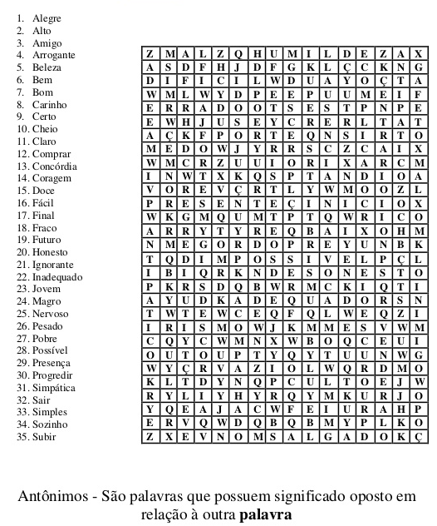

Ortografando!

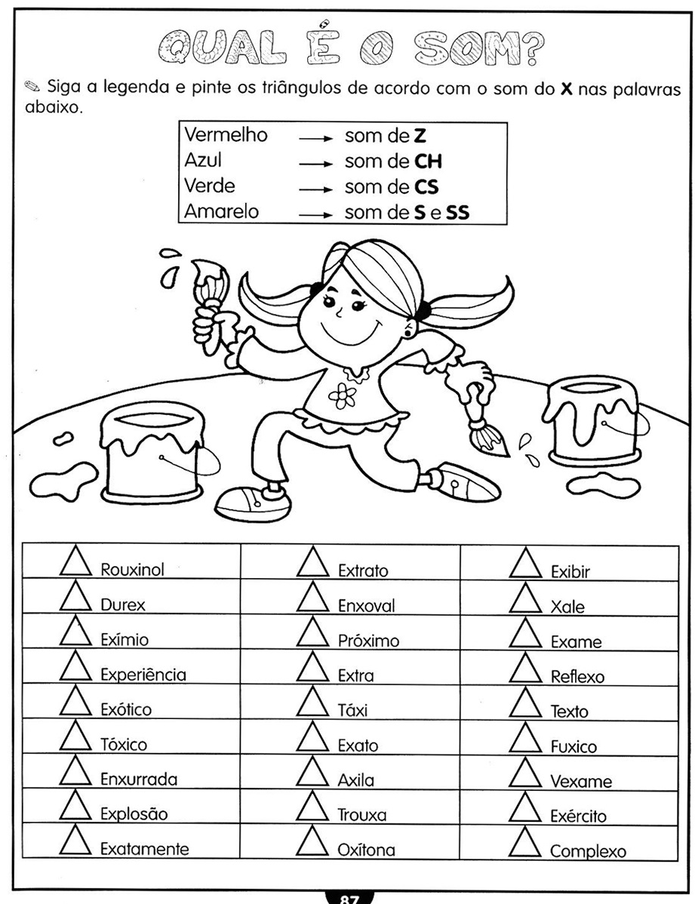

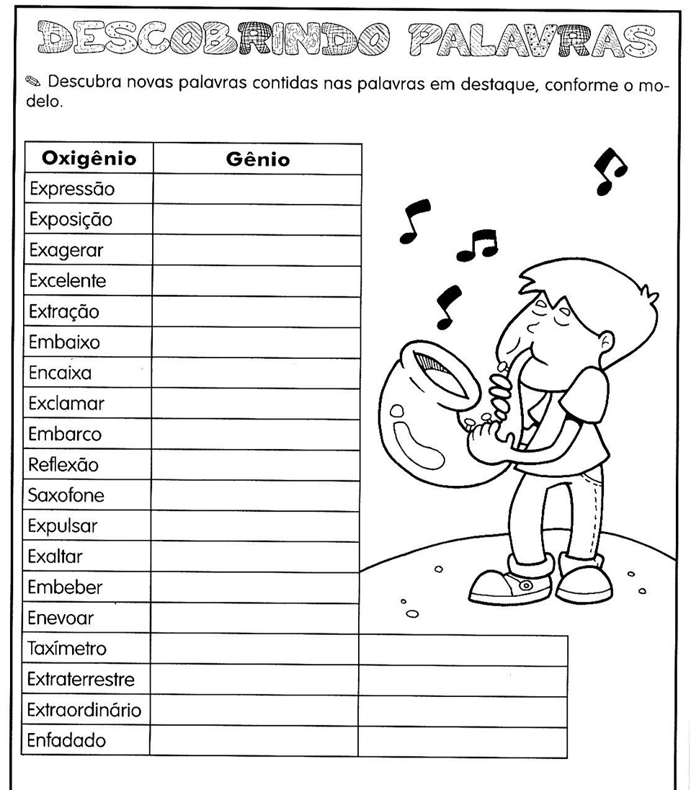

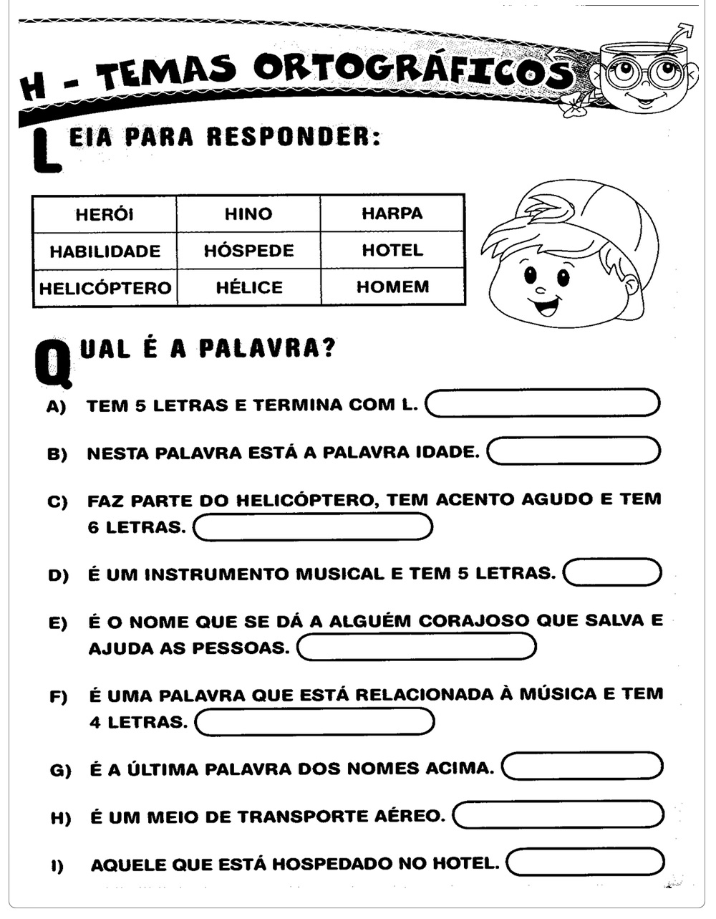

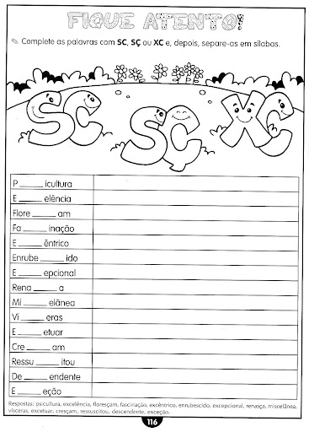

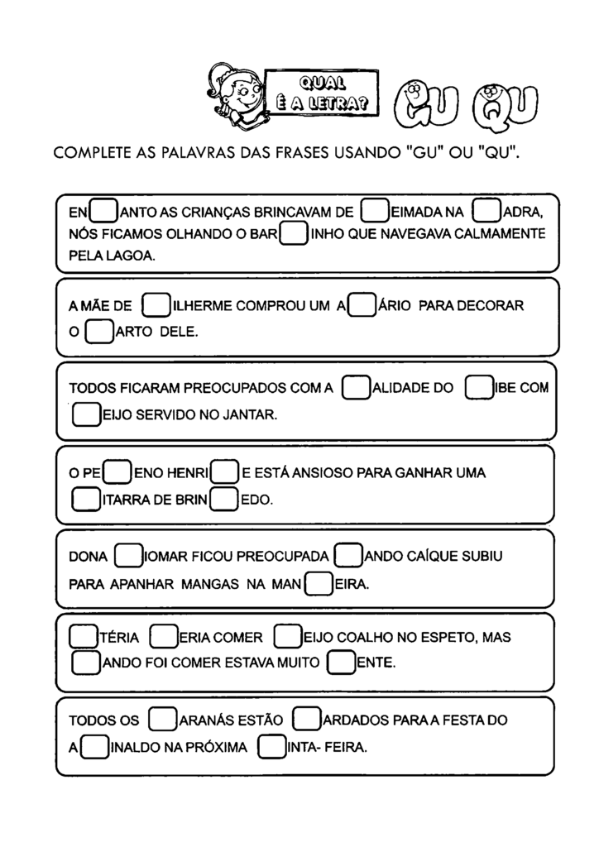
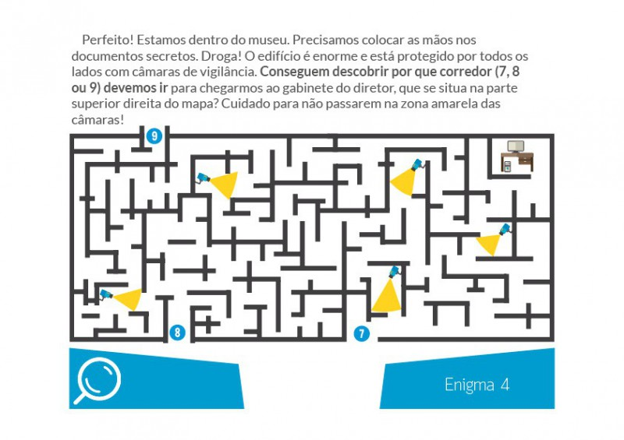

Beijos, tias, Fernanda e Jéssika.

